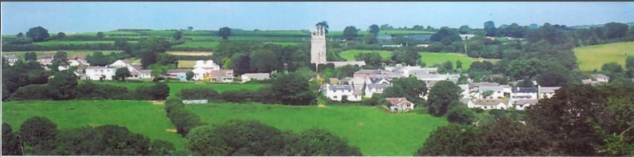
24th February 2026
Dear Councillor,
You are summoned to attend a meeting of North Hill Parish Council on Monday 2nd March 2026 at 7.30pm in the Village Hall.
Please find attached the agenda for our meeting. We ask that if any member of the public has issues, they would like to raise that they contact the clerk prior to the meeting so that we can best manage them.
Please remember that the time allotted for Matters of Community Concern is not a forum to discuss what has taken place during this meeting and that any matter raised here would likely be added to the NEXT meeting agenda for discussion.
Yours faithfully,
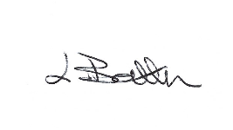
Lena Batten, Clerk to the Council
Members of the public are welcome to attend the meeting. However, we would like those attending to register prior to the meeting by emailing the Parish Clerk. Email: clerk@northhillparish.org.uk
AGENDA
- TO RECEIVE APOLOGIES:
- CODE OF CONDUCT: a) TO RECEIVE DECLARATIONS b) TO GRANT DISPENSATIONS:
3. PUBLIC COMMENTS ON ITEMS ON THE AGENDA ONLY:
4. TO RECEIVE AND APPROVE THE MINUTES OF THE 2ND FEBRUARY 2026 FULL COUNCIL MEETING:
5. ANY MATTERS ARISING FROM PAST MINUTES NOT ON THE CURRENT AGENDA:
6. TO CONSIDER PLANNING APPLICATIONS RECEIVED FROM CORNWALL COUNCIL BY DATE OF THIS MEETING:
6.1 To note for information - PA25/08719 - Battens Mill, Mill Lane, North Hill, PL15 7NU - Proposal Listed building consent to re-roof the property to ensure it remains weather-tight and prevent loss of historic fabric - approved.
6.2 To note for information - PA26/00413 - Trebartha Barton, North Hill, PL15 7PD - Proposal Submission of details to discharge Condition 3 in respect of Decision Notice PA24/08417 dated 15.01.2025 – S52/S106 and discharge of condition.
6.3 To note for information - PA25/09208 - Land North West of Clampit Farm, Linkinhorne, PL17 8QR -
Proposal Construction of a general purpose agricultural building and retention of works already executed including the construction of a stone access track and stone hard standing – approved.
7. ANY APPLICATIONS RECEIVED BEFORE THE DATE OF THIS MEETING: None.
8. TO REVIEW CORRESPONDENCE AND TO AGREED RESPONSES REQUIRED:
8.1 To accept / resolve any actions following the January 2026 Kompan inspection report.
8.2 To note for information the LMP grant has been accepted at £674.57 a 2.2% increase for cutting of
the footpaths for 2026-2027.
8.3 To consider / resolve whether to produce a neighbourhood priority statement as requested by
neighbourhood planning.
8.4 To obtain an update in relation to North Hill Parish Council’s Emergency Planning Procedures.
8.5 To confirm all new email addresses must be in use by the 31st March 2026 in order to be Assertion
10 compliant and confirm a date for transfer.
8.6 To review / adopt North Hill Parish Council’s IT Policy in order to be Assertion 10 compliant.
8.7 To note for information the ROSPA annual play area inspection is booked for April 2026.
8.8 To consider / resolve whether any Councillors wish to attend ROSPA training to enable them to be
accredited inspectors to carry out the play ground check.
8.9 To note for information the expression of interest for CIL funding is confirmed to have been
submitted with a reference number of CILF5101.
8.10 To consider / resolve a new date for April 2026 meeting as CALC have confirmed meetings cannot
take place on Tuesday 7th April.
8.11 To consider / resolve a request from a member of the public in relation to a street lamp which needs
fixing at Lynher Close.
9. TO REVIEW DETAILS FOR NORTH HILL PARISH COUNCIL CEMETERY:
9.1 To review the tender’s received to date for the creation of the footpath to date and consider /
resolve next steps.
10. APPROVAL OF THE LIST OF PAYMENTS / RECEIPTS FOR FEBRUARY 2026 & TO RECEIVE FEBRUARY 2026 BANK STATEMENT:
10.1 AUTHORISATION OF EXPENSES INCLUDING SALARY:
i) £18.00 (PAYE G. Pollard payroll, dd)
ii) £to be confirmed on receipt of payslip (Lena Batten, Salary Feb)
iii) £43.64 (room rent)
iv) £to be confirmed on receipt of payslip (Lena Batten, N.I. and tax Feb)
v) £64.99 (Lena Batten, Amazon, purchase of climbing net)
vi) £48.00 (annual bleed kit fee for defib, Bleed control UK
vii) £132.97 (Kompan quarterly play area check)
viii) £238.80 (extended two year warranty, Elan City)
ix) £15.00 (CALC, Assertion 10 training, clerk)
10.2 RECEIPTS:
None.
10..3 To receive February 2026 bank statement:
Bank Statement as of 20th February 2026 £15,369.92
11. TO REVIEW MONTHLY BUDGET RECONCILIATIONS:
11.1 Budget Sheet Attached.
12. TO REVIEW MONTHLY RAG: (Red, Amber, Green)
12.1 RAG Sheet attached.
13. REPORT FROM CORNWALL COUNCIL WARD MEMBER COUNCILLOR PARSONS:
14. ITEMS FOR INCLUSION AT THE NEXT MEETING:
15. DATE & TIME OF NEXT MEETING:
16. CLOSE OF BUSINESS:

